Ideation Phase
Empathize & Discover

Date | 27 February 2026
Team ID | LTVIP2026TMIDS65832
Project Name | Flight Finder
Maximum Marks | 4 Marks

Empathy Map Canvas:
Who are we empathizing with?
- Primary: Air travelers looking to find and book flights easily.
- Secondary: Admins managing flight schedules and bookings.

What do they THINK & FEEL?
- Worry about getting the best price and avoiding hidden fees.
- Nervous about cancellations, refunds, or schedule changes.
- Appreciate transparency, trustworthiness, and quick results.
- Value the ease of comparing flights on one platform.

What do they SEE?
- Multiple fragmented platforms (different airline websites, travel portals).
- Overwhelming number of options without clear comparisons.
- Promotional emails or ads promising “cheap flights.” • Peers using online booking
tools to plan trips.

🗣 What do they SAY & DO?
- “I want the best deal, but I don’t want to be scammed.”
- “Can I trust this site with my payment info?”
- Share screenshots with friends/family to compare options.
- Frequently ask about cancellation policies and support.

What do they HEAR?
- Friends: “I found a cheaper flight on another site.”
- Travel bloggers & social media posts promoting deals.
- Stories of bad experiences: hidden fees, denied refunds.

Example:
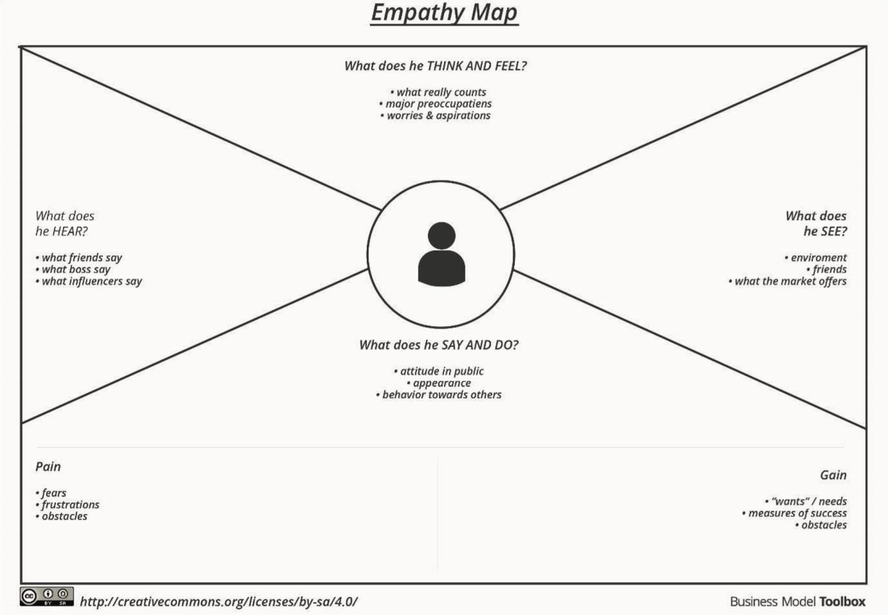

Example: Flight Finder Application
